**Lab 2 Report**

**Introduction:**

In this lab, we embark on the practical application of control principles to achieve precise position tracking of a cart system. Our objective is to design and implement state feedback and observer-based output feedback controllers that enable the cart to follow a square wave reference signal, thereby oscillating between two set points on a linear track. Utilizing a DC motor-driven system modeled with mass, viscous friction, and actuator dynamics, we explore the theoretical design of these controllers through eigenvalue assignment for system stabilization. Subsequent simulation in Simulink and experimental validation using Arduino provide a comprehensive understanding of the controller's performance in real-world conditions. This report delineates the systematic approach from mathematical modeling and controller design to the final implementation and tuning, ensuring that the cart maintains the desired trajectory with minimal error.

**Block Diagram of Closed Loop System:**

Figure 1: Block Diagram of Closed Loop System

The Simulink diagram lab2_part2 represents a closed-loop system with an output feedback controller designed to track the position of a cart system. The state equations that describe the behavior of this system are as follows:

Let $\dot{x}$ be the state vector, u be the control input, y be the measured output, and $\hat{x}$ be the estimated state from the observer. The system's dynamics can be described by the plant, the observer, and the controller state equations:

1. Plant State Equation:

$\dot{x}$ = Ax + Bu

Where:

- A is the state matrix of the plant,

- B is the input matrix,

- u is the control input.

2. Output Equation:

y = Cx + Du

Where:

- C is the output matrix of the plant,

- D is the direct transmission matrix (often zero in control systems).

3. Observer State Equation:

$\dot{\hat{x} }$ = A $\hat{x}$ + Bu + L(y - C $\hat{x}$)

Where:

- L is the observer gain matrix,

- y - C $\hat{x}$ is the measurement residual or estimation error.

4. Controller Equation:

u = K( $\hat{x}$- $x_{d}$)

Where:

- K is the feedback gain matrix,

- is the desired state vector which includes the reference input,

- - is the error between the estimated state and the desired state.

The overall closed-loop system aims to minimize the error between the actual state x and the desired state $x_{d}$, by adjusting the control input u based on the state estimate $\hat{x}$ provided by the observer. The plant dynamics follow the applied input u and produce the output y, which is fed back into the observer to update the state estimate. This forms a loop that continuously seeks to adjust the cart's position to follow the desired square wave trajectory.

**Lab Result:**

* Output 1 Analysis:

Through MATLAB-based calculations, we found the gains for our state feedback controller:

$K_{1}$ = -11.8897, $K_{2}$ = 1.3258

These gains position the eigenvalues of *A + BK* at {-5, -5}. Utilizing these values, we generated plots for z(t) and (t), and (t):

Figure 2: vs time (t)

Figure 3: $z\left(t\right) and z_{d}\left(t\right)$ vs time (t)

- In the initial response cycle, the system's output $z_{d}$ reached a settling point of 0.0288, calculated by 0.03 - 0.06 × 0.02 = 0.0288, at t = 6.168 seconds. The corresponding settling time is determined by 6.168 - 5 = 1.168 seconds.

Upon revising the controller with eigenvalues set at {-2, -2}, the settling time was observed to be 7.962 - 5 = 2.962 seconds. The ratio of the settling times $\frac{T_{s1}}{T_{s2}}$ = 0.39, which aligns closely with the expected ratio of 0.4. This observation is consistent with control theory, where settling time is inversely related to the magnitude of the controller's pole locations. Given that the proportional control values satisfy $\frac{{ P}_{1}}{{ P}_{2}}$ = $\frac{-5}{-2}=2.5$, we can deduce a proportional relationship $\frac{T_{s1}}{T_{s2}}$ = ${ (\frac{{ P}_{1}}{{ P}_{2}})}^{-1}$, validating our empirical results.

- Output 2 Analysis

- We computed the following gains for our state feedback controller and observer, with p_feedback = [−2 − 2] and p_observer = [−20 − 20]:

- State feedback gains: $K_{1}$ = -1.9023, $K_{2}$ = 4.1793

- Observer gains: $L_{1}$ = 27.2123, $L_{2}$ = 52.0169

- The matrices for the controlled system are:

- : [ ]

- : []

- : []

- : []

- Plots from the three Simulink scopes with p_feedback = [−2 − 2] and p_observer = [−20 − 20]:

Figure 4: Motor Voltage Magnitude (V) vs Time (s) with p_feedback = [−2 − 2] and p_observer = [−20 − 20]

Figure 5: $z\left(t\right) and z_{d}\left(t\right)$ vs time (t) with p_feedback = [−2 − 2] and p_observer = [−20 − 20]

Figure 6: Tracking Error vs time (s) with p_feedback = [−2 − 2] and p_observer = [−20 − 20]

The tracking error exhibited a maximum value of $1.923 × {10}^{-14} ( 2.28221 × {10}^{-14}-3.5921 × {10}^{-15}=1.923 × {10}^{-14})$ by using cursor measurement tool, and the peak voltage magnitude applied to the motor was observed to be 0.272533 volts.

- Plots from the three Simulink scopes with p_feedback = [−5 − 5] and p_observer = [−20 − 20]:

Figure 7: Motor Voltage Magnitude (V) vs Time (s) with p_feedback = [−5 − 5] and p_observer = [−20 − 20]

Figure 8: $z\left(t\right) and z_{d}\left(t\right)$ vs time (t) with p_feedback = [−5 − 5] and p_observer = [−20 − 20]

Figure 9: Tracking Error vs time (s) with p_feedback = [−5 − 5] and p_observer = [−20 − 20]

- After altering the eigenvalues of A + BK to p_feedback = [-5 -5], we noted the following:

The tracking error exhibited a maximum value of $9.1267 × {10}^{-10} ( 1.07027 × {10}^{-9}-1.576 × {10}^{-10}=9.1267 × {10}^{-10})$ by using cursor measurement tool, and the peak voltage magnitude applied to the motor was observed to be 0.775907 volts.

Changing the eigenvalues of A + BK to p_feedback = [-5 -5] had a significant impact on the system's performance:

- The increase in tracking error maximum value indicates a change in the system's response to the reference signal, potentially due to a slower reaction or a decrease in system damping.

- The higher peak voltage magnitude |u(t)| suggests that the controller is exerting more effort—applying higher voltages—to bring the system to the desired state.

This behavior is expected as moving the eigenvalues further left in the complex plane usually results in a faster system response but can also lead to more aggressive control actions, which may not always be desirable due to physical constraints or the risk of inducing more oscillations. Ignoring the first period of the square wave allows us to focus on the system's steady-state behavior, which is crucial for understanding the long-term performance of the controller.

- Plots from the three Simulink scopes with p_feedback = [−2 − 2] and p_observer = [−10 − 10]:

Figure 10: Motor Voltage Magnitude (V) vs Time (s) with p_feedback = [−2 − 2] and p_observer = [−10 − 10]

Figure 11: $z\left(t\right) and z_{d}\left(t\right)$ vs time (t) with p_feedback = [−2 – 2] and p_observer = [−10 − 10]

Figure 12: Tracking Error vs time (s) with p_feedback = [−2 − 2] and p_observer = [-10 − 10]

- After reverting the eigenvalues of A + BK to p_feedback = [-2 -2] and change the eigenvalues of A − LC, setting p_observer = [−10 − 10], we noted the following:

The tracking error exhibited a maximum value of $6.93889 × {10}^{-18} ( 6.93889 × {10}^{-18}-0=6.93889 × {10}^{-18})$ by using cursor measurement tool, and the peak voltage magnitude applied to the motor was observed to be 0.272296 volts.

When the eigenvalues of A - LC were changed to p_observer = [-10, -10], it significantly improved the state estimation accuracy, as indicated by the reduced maximum tracking error. A smaller tracking error implies that the observer is more effectively estimating the system states, which allows the controller to adjust the system output more accurately to follow the desired trajectory z_d(t).

Furthermore, the slight adjustment in the peak voltage magnitude indicates that the control actions remained nearly consistent with the previously observed values, suggesting that the controller maintains a similar level of effort to achieve the desired performance.

The primary effect of these observer eigenvalue adjustments on the state estimation error $x-\hat{x}(t)$ would likely be an enhanced rate of convergence for the observer's estimates to the true state values. By placing the observer poles further to the left on the s-plane, the dynamics of the observer are made faster relative to the system, which should theoretically improve the observer's response time and reduce estimation error, leading to more precise control actions and potentially better overall system performance.

- Output 3 Analysis

Trial and Error Procedure:

During the tuning phase of our control system, we utilized a trial-and-error method, initially setting p_feedback = [−5 − 5] and p_observer = [-10 − 10]. The cart's response under these parameters was suboptimal, exhibiting less movement than expected. Recalling that increasing p_feedback enhances the motor voltage, we adjusted p_feedback to [-10, -10] to quicken the cart's speed and diminish the settling time. However, this adjustment led to less accurate cart movement, with variations observed in each cycle. To mitigate this, we elevated p_observer, which refined the precision of state estimation. The optimal performance was attained with p_feedback = [−10 − 10] and p_observer = [-20 − 20].

Experimental Results:

Figure 13: Position (m) vs Time (s) with best parameters

The experimental plot demonstrated a considerably short settling time of approximately 0.2 seconds, and the deviation between the expected and actual displacement was within acceptable limits. The experimental setup, tuned with the identified optimal parameters, showcased a satisfactory tracking performance, closely following the desired trajectory with minimal error.

Simulation Results:

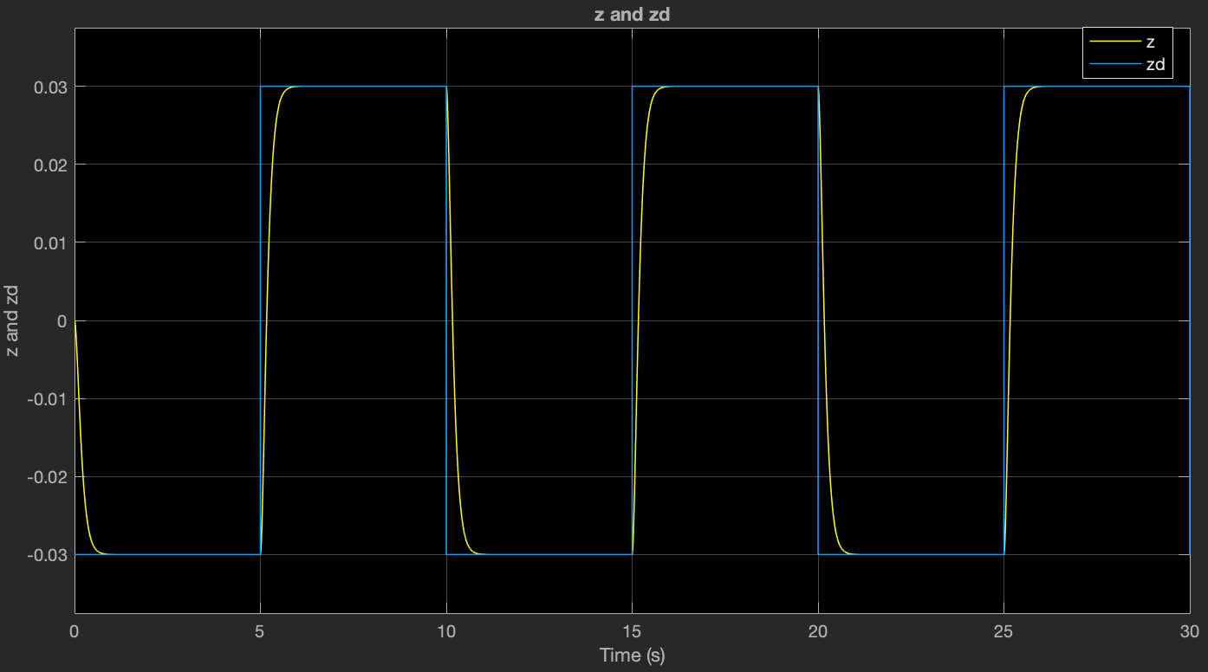

Figure 14: Simulation Plot of output signal y(t) and the reference signal $z_{d}$ (t)

Contrastingly, the simulation predicted a longer settling time, around 0.5 seconds, with an anticipated exact movement magnitude of 0.03. Such differences between the simulation and experimental results are informative. The simulation operates under idealized conditions, such as a frictionless environment, which does not perfectly mirror the real-world scenario.

The divergence between experimental and simulated outcomes could be traced back to several factors. The assumption of frictionless motion in the simulation likely introduced a disparity from the physical experiment, which encounters real friction. Additionally, variations in the motor input—potentially due to hardware limitations or signal noise—might have influenced the experimental accuracy. These findings underscore the necessity to account for practical limitations within theoretical models and suggest avenues for refining the simulation to better align with the empirical results.

Further iterations of the controller tuning process might incorporate more sophisticated techniques, such as adaptive control strategies or the inclusion of friction compensation in the model, to enhance the congruence between the simulation and the actual performance and achieve even more precise control of the cart system.